  - FdSc Sports Studies

University Centre Weston
  - in partnership with
University of the West of England
(Hartpury College)

Academic Year: 2014/15

Programme Handbook

This handbook is published for students studying at University Centre Weston on the above programme and is available in a range of alternative formats on request.

Contents
1 Introduction 1
Welcome 1
Purpose of the Handbook 1
2 Course content 2
Course Distinctiveness 2
Curriculum 2
3 Course aims 5
General Aims 5
Specific Aims 5
Learning and Teaching Methods 6
Interim Awards 7
Progressing onto Honours Degree 7
4 Learning Environment 8
Work-based Learning 8
5 How is Quality assured? 9
Quality monitoring and evaluation 9
External examiners 9
External references 10
6 Appendices 11
Appendix one - Marking Criteria 11
Appendix two – Module specifications 11
Appendix Three – Policies and Procedures 11

Introduction

Welcome
Welcome to the FdSc Sport Studies Degree. This course is offered in partnership between University of the West of England and University Centre Weston (UCW). You are a registered student at University of the West of England and at UCW, and you have access to services at both institutions.

Purpose of the Handbook
This handbook gives you essential background information that will be of help in your studies on the FdSc Sport Studies programme. It provides links to the definitive data sources wherever possible. The handbook can be accessed via your VLE account.
Please note that the electronic version will be kept up to date and you will be notified of any significant changes. If you have taken a hard copy of any information please remember to refer back to the electronic version to ensure that you are working with the most up to date information.
For module information please see the respective Module Handbook.

Course content

Course Distinctiveness
This course is designed to challenge you in a number of different ways. We make no excuse of taking you out of your comfort zone by developing your skills in both a practical and theoretical setting. This is done gradually so that by the end of your programme you will have developed the knowledge and the confidence to progress either onto a top-up year at UWE (Hartpury) or into full-time employment within the Sports industry.
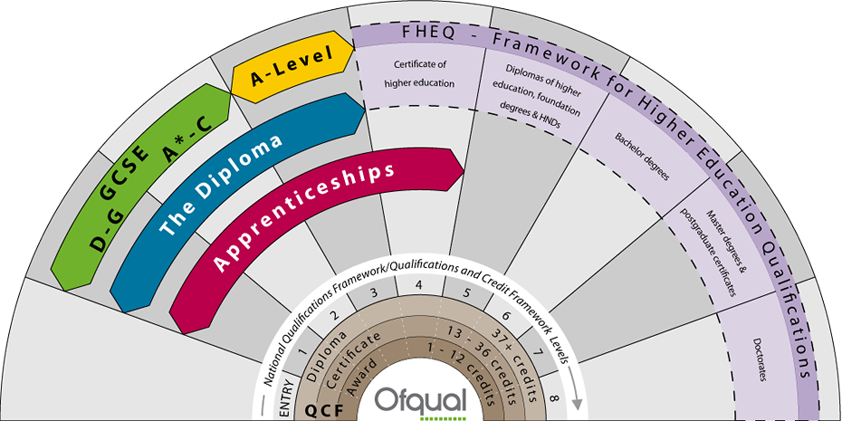
Figure 1: Framework for Higher Education Qualification
This course has been designed with employability in mind and has been written to enable students to engage with the issues and developments affecting the Sports industry. Its vocational focus allows students to spend a significant amount of time within the workplace in order to gain experience, manage a variety of small projects and develop a range of skills. A vocational approach is underpinned by academic theory and industry standards which allow students to assess situations, make comparative judgments and suggest a range of alternative approaches. The modules have been designed to deliver a balance of theory and practical experience of key aspects of the Sports industry.

Curriculum

Year One
Full time
Year 1 of study
Level | Title | Credits | Code
1 | Sports Coaching | 30 | UISXPN-30-1
1 | Psychology of Sports Performance | 15 | UISV9G-15-1
1 | Performance Analysis Fundamentals | 15 | UISV8X-15-1
1 | Strength and Conditioning | 30 | UISXP9-30-1
1 | Sport Studies Work Experience 1 | 30 | UISXPE-30-1

Year Two
Full time
Year 2 of study
Level | Title | Credits | Code
2 | Sports Entrepreneurship | 30 | UISXPQ-30-2
2 | Sport, Exercise and Health Pedagogies | 30 | UISXPR-30-2
2 | Sports Injuries and Rehabilitation | 15 | UISXPT-15-2
2 | Principles of Sports Nutrition | 15 | UISXPV-15-2
2 | Research Methods | 15 | UINXPU-15-2
2 | Sport Studies Work Experience 2 | 15 | UISXPP-15-2
All HE programmes at University Centre Weston are delivered as a collection of modules, which build on each other to form a complete programme of study. Each module carries a credit rating, defining how much study time it takes to complete. Notionally, 1 credit equates to 10 hours study time (so 10 credits = 100 study hours). “Study hours” includes lectures, seminars, tutorials, group work, independent study and research – in fact, any time that contributes to your learning on the module.

Link Tutor
Each programme has an identified link tutor from its validating partner University whose role it is to support the Weston team. The link tutor for your programme is:
Mike.Green | Mike.green2@hartpury.ac.uk

Course aims
Over the 2-years of studying, this course aims to complete the following aims;
FdSc Sports Studies is a two year full-time or three-year part-time programme designed to develop a sound general knowledge of the world of sport, sport education and associated professions, whilst developing knowledge, skills and experience for a career in the field of sport and education.

This programme will provide an opportunity to progress to level 3 BSc (Hons) Sports Studies at Hartpury College.

General Aims
The programme will enable students to:
- Develop knowledge and understanding of contemporary key sport, exercise and education concepts, theories and approaches.
- Develop a sound understanding of the scientific principles that govern biological, physical, sociological and psychological stressors in a sports studies context.
- Develop academic, professional, generic, practical and employability skills which will equip students for gaining employment within a variety of career pathways associated with the sports industry and being successful at work.
- Engage with the necessary qualitative and quantitative skills to critically analyse sports studies research with which to inform evidence-based practice.
- Provide students with a broad and balanced knowledge and understanding of sports provision in the context of national initiatives and local schemes within the Public, Private and Voluntary sectors to promote an understanding of the management and provision of sports studies and development locally, regionally, nationally and internationally.
- Prepare for progression to study higher degrees in Sports Studies and other related subjects.
- Engage with Sports Studies practice in a variety of settings.

Specific Aims
The specific aims of the programme are to:
- Facilitate the development of a scientific and educational understanding of the principles and processes that underpin sports studies.
- Develop an understanding of the subject of Sports Studies from a multidisciplinary and interdisciplinary perspective.
- Develop the ability to assess health and select the most appropriate intervention option from a range of possible solutions.
- Demonstrate investigative skills necessary to undertake independent investigations of sports studies problems.
- Provide the opportunity for the acquisition and practice of appropriate transferable skills and facilitate the development of independent and team working.
- Provide the opportunity for the development and practice of employability and professional skills through work based experience.
- Provide a curriculum that is enhanced by experience from research, consultancy and professional practice.
Promote and widen access to careers in Sports Studies to applicants with non-standard entrance requirements.

Learning and Teaching Methods
UCW has a Learning and Teaching Strategy for Higher Education, which underpins our approach.
We intend that the learning programme should be both stimulating and demanding, and should lead you through progressive stages of development, towards increasingly complex and open-ended tasks, increasingly sophisticated application of intellectual/conceptual and personal (transferable) skills, and increasingly independent study.
A variety of learning methods will be used, which might include:
- Lectures
- Seminars
- Experiential learning
- Reflective learning
- Skills practice
- Group work and group discussions
- Workshops
- Case studies
- Student presentations
- Information and communications technology (ICT) based activities

Interim Awards
Students who do not complete the course but successfully achieve at least 120 credits will be eligible to receive the interim award of a Certificate of Higher Education

Progressing onto Honours Degree
You can ‘top-up’ your FdSc degree to a BSc (Honors) degree by an additional year of study.
To be eligible for progression you must have gained 240 credits, 120 credits at Level 4 and 120 credits at Level 5. The deadline for applications is usually on or before 1st May in the final year of Foundation Degree studies.
Your tutor will arrange a meeting with the Course Leader at Hartpury College to discuss the modules on offer on the top-up degree and answer any questions that you may have. You are also welcome to visit the campus and meet with staff and students.

Learning Environment

Work-based Learning
Work based learning will be completed in both years of your foundation degree. It is expected as a minimum, you will complete 160-hours in your first year and 100—hours in your second year. You can conduct your work experience in any sector of the sports industry, however, it must be within a role that you can develop your professional skills and in a position that improves your employability status when you leave formal education. If you require any further guidance on the concept of WBL or if you need assistance with gaining a placement either speak to your module or programme leader.

How is Quality assured?

Quality monitoring and evaluation
The programme you are studying was approved by University of the West of England. As part of the approval process it was assured that
- the content of the programme met national benchmark requirements;
- the programme met any professional/statutory body requirements; and
- the proposal met other internal quality criteria covering a range of issues such as admissions policy, teaching, learning and assessment strategy and student support mechanisms.
This was done through a process of programme approval which involves consulting academic experts including subject specialists from other institutions and industry.

How we monitor the quality of this programme
The quality of this programme is monitored each year through evaluating:
- external examiner reports (considering quality and standards);
- statistical information (considering issues such as the pass rate); and
- student feedback including the National Student Survey (NSS).
Drawing on this, and other, information programme teams undertake an annual monitoring process, in accordance with the University's quality policy.
Once every six years an in-depth review of the subject area is undertaken by a panel that includes at least two external subject specialists. The panel considers documents, looks at student work, speaks to current and former students and speaks to staff before drawing its conclusions. The result is a report highlighting good practice and identifying areas where action is needed.

The role of the Programme Committee
This course has a Programme Committee comprising all relevant teaching staff, student representatives and others who make a contribution towards its effective operation (e.g. library/technician staff). The Programme Committee has responsibilities for the quality of the programme and plays a critical role in the University's quality assurance procedures.

External examiners
The standard of this programme is monitored by a number of external examiners, who are subject specialists from other HE institutions. External examiners have two primary responsibilities:
- To ensure the standard of the programme;
- and ensure fairness and equity
The external examiners for your programme are:
Name | Name of institution
Dr Andy Adcroft | University of Surrey
Dr Craig Twist | University of Chester
Mr M McCreadie | University of Glasgow
Mr Will Katene | University of Exeter

External references
The following methods are used for gaining the views of other interested parties:
- Feedback from former students;
- Feedback from employers;

Appendices

Appendix one - Marking Criteria
Marking criteria will be allocated to you in induction week and they can be found on the VLE

Appendix two – Module specifications
Module specifications can be found on the VLE for each of your year one and year two modules.

Appendix Three – Policies and Procedures
Policies relating to HE Students can be found on Moodle at:
https://moodle.weston.ac.uk/mod/glossary/view.php?id=93970

