Policy and Procedures
UCW Publishing Statement

2021 – 22

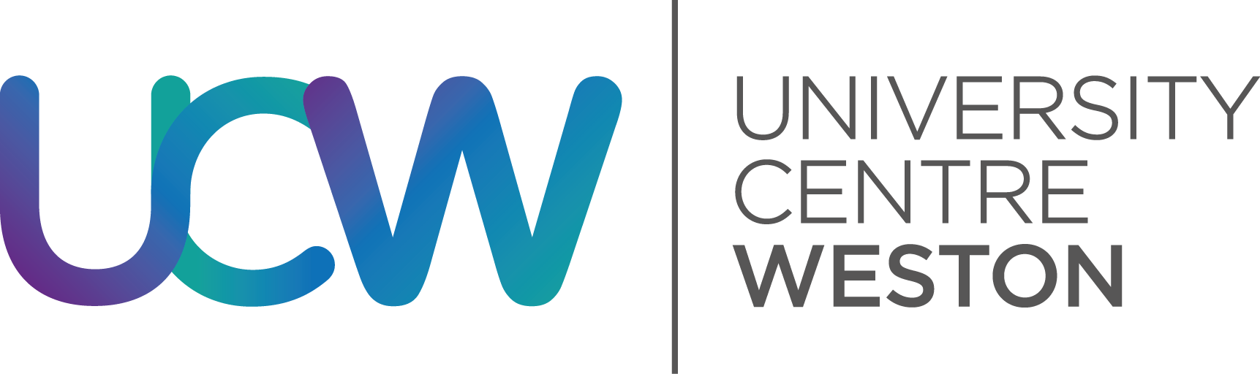

Document Consultation |  | Approval | Dissemination
HEDMT | STUDENT engagement | CLB | CLB  (For info)
16/04/18 | TBC | 23/03/2018 | 23/03/2018
Review Date: February 2021

UCW PUBLISHING STATEMENT

- Purpose and scope
Weston College of Further and Higher Education (hereafter known as Weston College) with University Centre Weston (UCW) seek to ensure that published materials in all formats are comprehensive, accurate, fully compliant with all relevant legislation and readily accessible. This is to ensure that all intended audiences (including students, prospective students, parents/guardians, members of the public and stakeholders) have access to objective and unbiased information on which to base judgements about UCW regarding applications and quality and standards.
UCW is committed to meeting the obligations laid out in the Competition and Markets Authority (CMA) ‘UK higher education providers – advice on consumer law’ guidance document.

- Published information the Weston College and UCW are responsible for
Weston College’s Marketing and Communications Department and UCW produce a range of published and electronic information about higher education provision.
All published information adheres to the policies and procedures of partner universities, which also assist in the marketing of programmes through their own channels.
Published information covered in this statement include, but are not limited to:
- UCW Prospectus.
- UCW website.
- Social media.
- News stories, press releases and other PR initiatives.
- Advertising and other marketing initiatives.
- Information booklets/leaflets for prospective/current students.
- Student Course Handbooks, Programme Handbooks and Module Handbooks.
Ultimate responsibility for the production and management of UCW’s published information lies with Weston College’s Head of Marketing and Communications and UCW’s Assistant Director HE: Academic Registry.

- Processes to ensure the accuracy of published information
Established procedures exist to check and monitor the accuracy and fitness for purpose of published information.

- UCW Prospectus
- The Head of Marketing and Communications, the Assistant Director HE: Academic Registry, the Digital and Creative Manager, HE Publications and Marketing Officer, the Marketing Officer: Graphic Design and the HE Widening Participation and Recruitment Officer meet to discuss the format of the Prospectus.
- The Digital and Creative Manager devises a timeline for the project.
- The Digital and Creative Manager and the Marketing Officer: Graphic Design begin work on graphics, cover and artwork, which are presented to the Vice Principal: Higher Education for approval.
- The HE Publications and Marketing Officer arranges the required photography and produces a first draft of the document, which is sent to the above post-holders for approval.
- The Marketing Officer: Graphic Design produces the first designed draft.
- The HE Publications and Marketing Officer sends this draft to the Curriculum/Programme Coordinators, Heads of Faculty and key staff within the Higher Education Directorate for accuracy checks.
- Amended versions of the document are worked on by the HE Publications and Marketing Officer and Marketing Officer: Graphic Design until all information is accurate and presented in an attractive and accessible format.
- The HE Publications and Marketing Officer shares the document with partner universities, the Head of Marketing and Communications, the Vice Principal: Higher Education and the Assistant Director HE: Academic Registry for final approval.
- This process leads to the production of a Prospectus approved by Weston College, UCW and partner universities.

- UCW website
- UCW has its own website (www.ucw.ac.uk) which was designed, developed and launched by the Digital and Creative Manager in 2016.
- The Digital and Creative Manager, Web Technician and HE Publications and Marketing Officer are able to make amendments and updates to the content on the UCW website.
- The website hosts every policy, procedure and regulation that UCW is required to make available to prospective and current students and the wider public under its consumer protection law obligations.
- Course pages also contain complete information about each programme, including all of the required material information identified by the CMA, and the relevant UCW and partner university terms and conditions.
- Curriculum/Programme Coordinators are required to check on the accuracy of their online course pages on an ongoing basis to ensure the information relating to their courses remains current and accurate.
- They are also sent reminder emails by the HE Publications and Marketing Officer at the start of each academic year to review the information on their pages and, where applicable, provide the up-to-date information.
- The HE Publications and Marketing Officer undertakes a full website audit twice a year (when the Prospectus is printed in March and at the beginning of the academic year in September).

- Social media
- Weston College has a Social Media Policy that all members of staff must familiarise themselves with and adhere to.
- UCW utilises Facebook, Twitter and Instagram (all @UCWeston) to communicate with prospective and current students and the wider public.
- UCW social media is administered by the Marketing and Communications Department, but the Deputy Academic Registrar: Higher Education, HE Publications and Marketing Officer, HE Widening Participation and Recruitment Officer and HE Student Engagement and Experience Officer are able to post directly to the page/accounts without prior approval.
- The HE Publications and Marketing Officer and the Digital and Creative Manager are able to advertise on UCW social media. All adverts must be approved by either the Head of Marketing and Communications or the Assistant Director HE: Academic Registry.
- A number of UCW Curriculum/Programme Coordinators also manage course/area-specific Twitter and Instagram accounts. They are responsible for publishing accurate information. When their content fails to meet Weston College’s standards, the Marketing and Communications Department is able to delete the account(s). When the staff who manage these accounts leave Weston College, passwords are changed to prevent them being able to continue accessing the accounts.

- News stories, press releases and other PR initiatives
- The HE Publications and Marketing Officer is required to generate a minimum of 20 general interest news stories per year to raise awareness of UCW in the wider public.
- When a Curriculum/Programme Coordinator has an event/story that they wish to promote, they provide the HE Publications and Marketing Officer with the facts and key contacts. The HE Publications and Marketing Officer then arranges for photography and produces the story, and seeks approval from the Curriculum/Programme Coordinator.
- The HE Publications and Marketing Officer then uploads the story to the news pages on the UCW website and shares via social media.
- If a story is deemed by the HE Publications and Marketing Officer to be of sufficient interest for wider public dissemination, they are able to seek approval from the Head of Marketing and Communications and the Assistant Director HE: Academic Registry for distribution to Weston College’s approved press and media contacts.
- The Marketing Coordinator: Content and Communication is also able to produce media releases about UCW and lead on other public relations initiatives after gaining prior approval from the Head of Marketing and Communications.

- Advertising and other marketing initiatives
- The HE Publications and Marketing Officer liaises with College-approved specialist agencies to identify advertising opportunities.
- The HE Publications and Marketing Officer decides upon the content of the advert(s) and request design/artwork from the Marketing Officer: Graphic Design.
- The Head of Marketing and Communications and the Assistant Director HE: Academic Registry approve all advertising initiatives prior to implementation.
- The Marketing Coordinator: Campaigns and Promotion is also able to lead on advertising and other marketing initiatives after gaining prior approval from the Head of Marketing and Communications.

- Information booklets/leaflets for prospective/current students
- UCW produces a number of information booklets and leaflets for prospective and current students on topics including student finance and the support services on offer at UCW.
- Requests for such materials are made by the Assistant Director HE: Academic Registry, Deputy Academic Registrar: Higher Education or HE Widening Participation and Recruitment Officer to the HE Publications and Marketing Officer, who leads on production of the materials.
- The HE Publications and Marketing Officer arranges for the required photography and produces the copy, which is sent to the Marketing Officer: Graphic Design for design.
- The information is verified by the Assistant Director HE: Academic Registry, who also approves the publication of the booklet/leaflet.

- Student Course Handbooks, Programme Handbooks and Module Handbooks
- The HE Curriculum and Quality Team, led by the Assistant Director HE: Curriculum and Quality, has overall responsibility for ensuring that Student Experience Handbooks, Programme Handbooks/Student Course Handbooks and Module Handbooks are fit for purpose, current and accurate.
- Curriculum/Programme Coordinators produce the Student Experience Handbooks, Programme Handbooks/Student Course Handbooks, with Module Handbooks produced by Module Leaders.
- Each document is checked by the HE Partnership and Compliance Manager for accuracy and completeness.
- The Student Experience Handbooks, Programme Handbooks/Student Course Handbooks are also confirmed by the Link Tutor from the relevant partner university.
- Once the documents are approved, they are uploaded to SharePoint and the relevant HE Moodle by the HE Digital Learning and Teaching Development Officer in accordance with the HE VLE Expected Standards.

